**Report and Documentation AI/ML task:**

IMDB Customer Dataset Sentiment Analysis Report:

**Project Overview**

This project focuses on sentiment analysis of the IMDB dataset, which contains 50,000 movie reviews labeled as positive or negative. The primary goal is to classify the sentiment of movie reviews using deep learning techniques, particularly TensorFlow and Keras.

**Dataset Description**

* **Source**: The dataset is sourced from Kaggle.
* **Size**: 50,000 movie reviews (25,000 positive and 25,000 negative).
* **Format**: Each review is labeled as either positive (1) or negative (0).

Data Cleaning

Text Normalization

We will perform the following cleaning steps:

Remove HTML tags.

Convert text to lowercase.

Remove punctuation and special characters.

Remove stop words.

Remove single characters and extra spaces.

**Code for Data Cleaning**

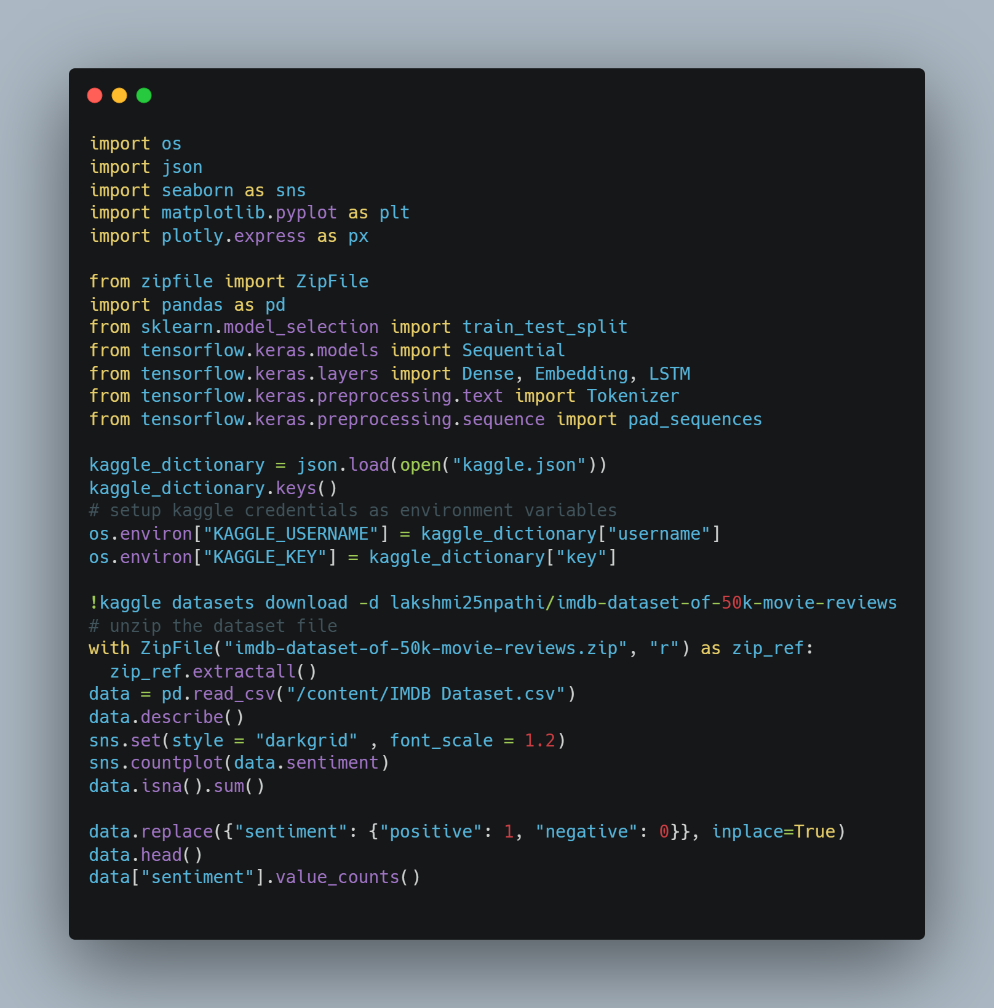

**Data Preparation**

**Tokenization and Padding**

We will tokenize the text data and pad the sequences to ensure uniform input length.

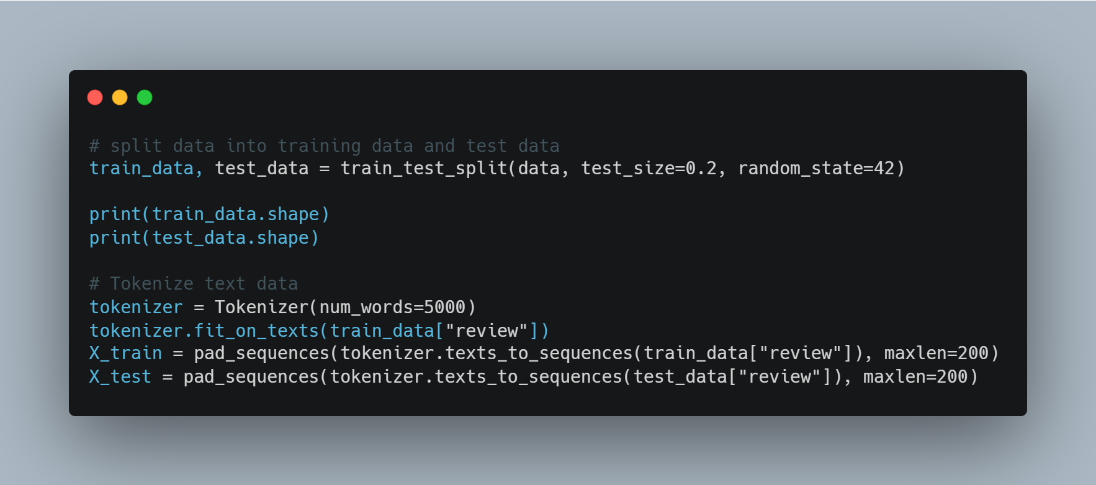

**Model Development**

**Building the LSTM Model**

We will build an LSTM model for sentiment classification.

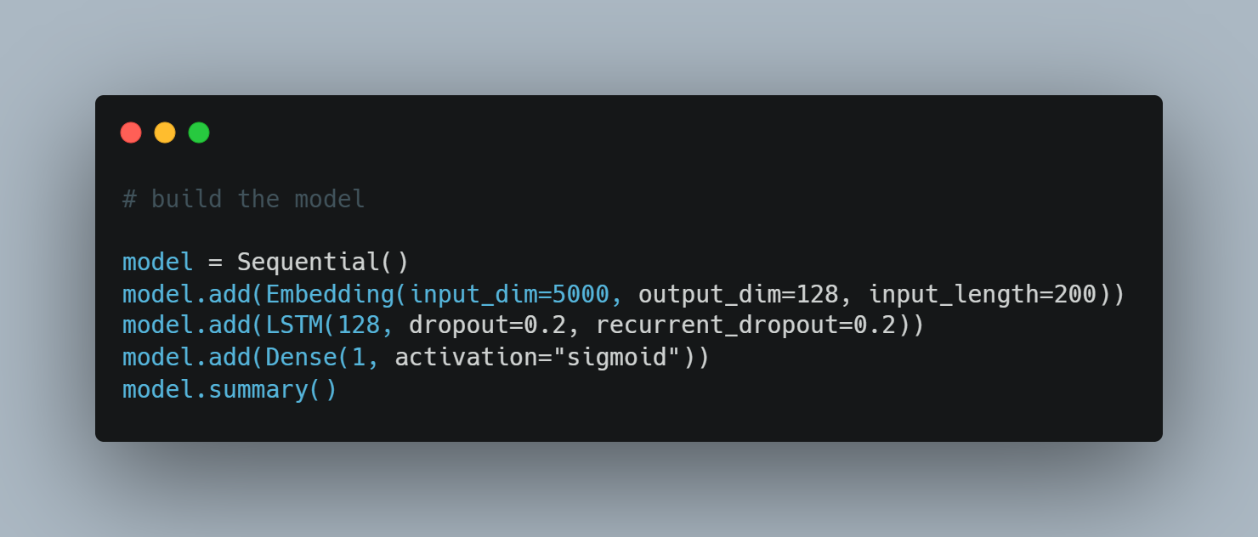

**Training the Model**

We will train the model using the training dataset.

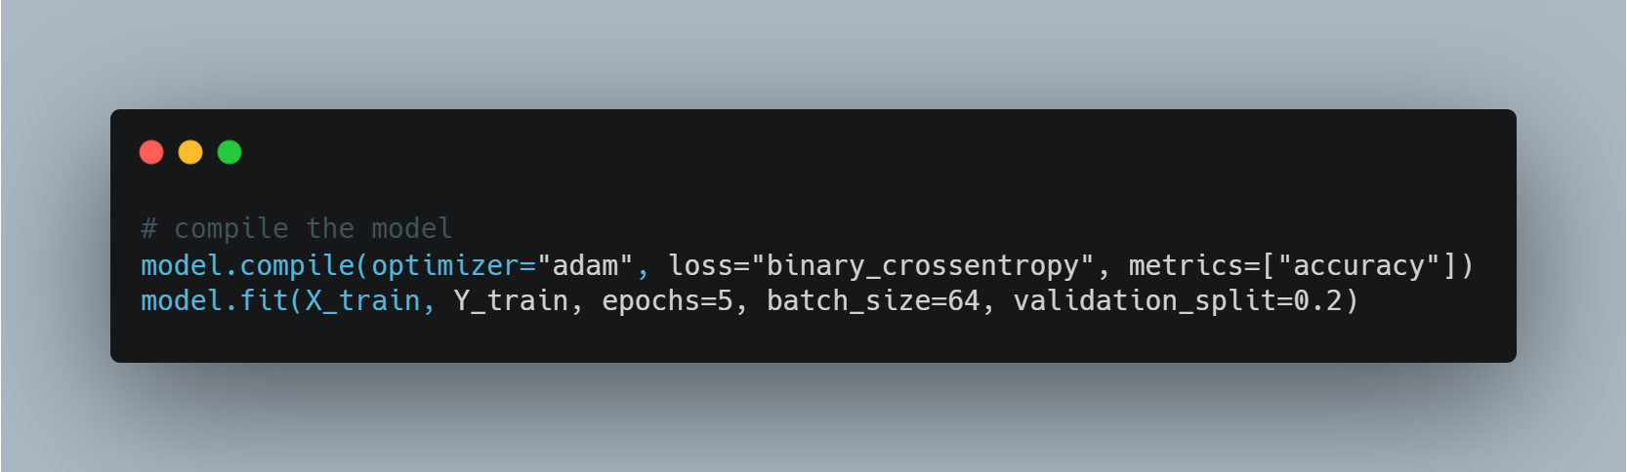

**Evaluation**

**Performance Metrics**

We will evaluate the model's performance based on accuracy.

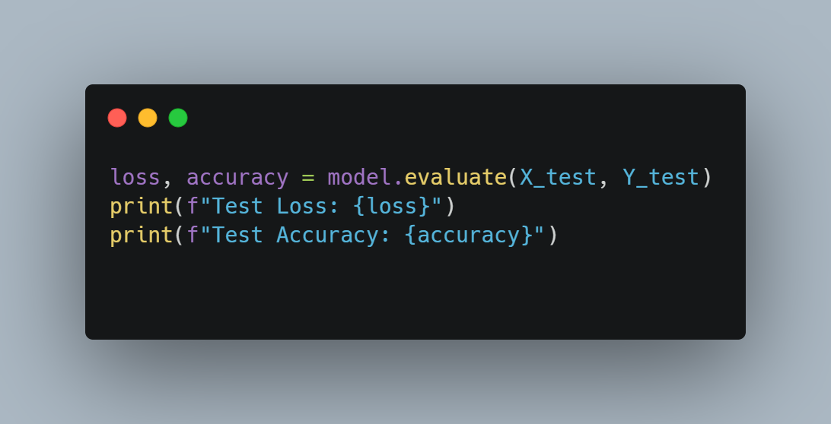

**Building a Predictive System** 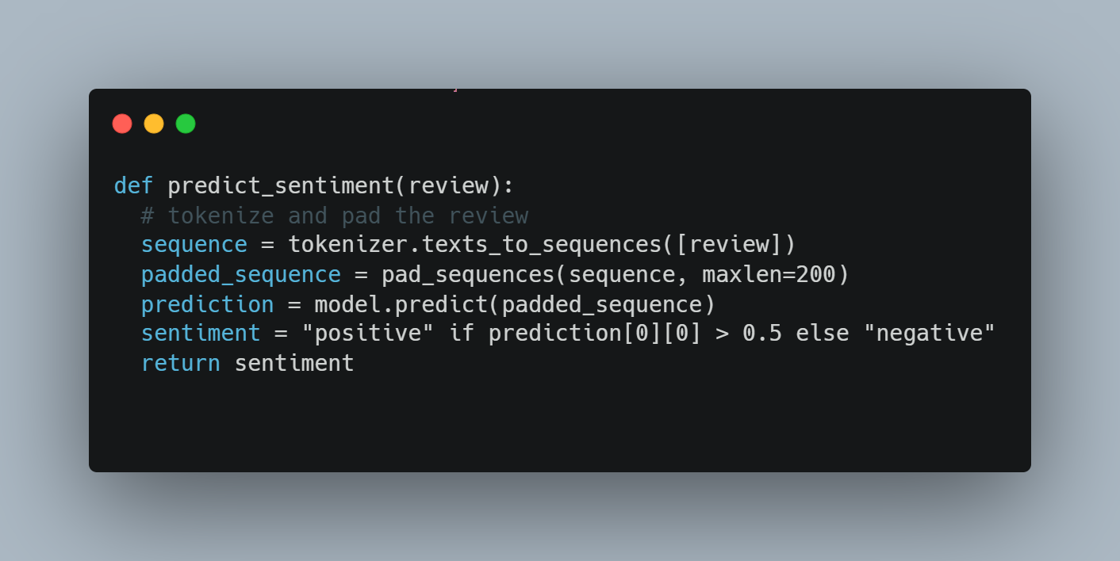

**Example Usage**

